To experimentally observe and analyze the performance of a zener regulated linear power supply in terms of its regulation, ripple and ripple rejection characteristics. The operation will be examined with and without an operational amplifier in the controlling feedback loop and the performance variations will be noted.

1.
Oscilloscope
2.
Half, Full Center Tap, and Full Wave Rectifier Board
3.
Ohmmeter (Fluke – 45)
4.
Powerstat-Variable Transformer 3 Amp
5.
2 Capacitors – 100 $μ$fd and
6.
Resistor - Pot
7.
Various lengths of hook-up wire and instrument leads as required

- Low line no load measurements (Variac Voltage = 105):
- V out-dc= 4.427V
- I Load= 0
- V-out-pp-ripple = 5.61mV
- V zener = 4.996V
- V zener-pp-ripple = 5mV
- V cf = 16.239V
- V cf-pp-ripple = 2.35V

- High line no load measurements (Variac Voltage = 120):
- V out-dc= 4.433V
- I Load= 0
- V-out-pp-ripple = 5.94mV
- V zener = 5.005V
- V zener-pp-ripple = 6.6mV
- V cf = 19.04V
- V cf-pp-ripple = 2.71V

- Low line no load measurements (Variac Voltage = 105 / R-load = 100 ohms):
- V out-dc= 3.953V
- I Load= 39.53mA
- V-out-pp-ripple = 5.9mV
- V zener = 4.984V
- V zener-pp-ripple = 26mV
- V cf = 13.978V
- V cf-pp-ripple = 7.85V

- High line no load measurements (Variac Voltage = 120 / R-load n= 100):
- V out-dc= 3.948V
- I Load= 39.48mA
- V-out-pp-ripple = 5.6mV
- V zener = 4.992V
- V zener-pp-ripple = 23.2mV
- V cf = 16.3V
- V cf-pp-ripple = 8.30V

Performance parameters for the power supply obtained from part (a) through (d) with the above calculations.
- The output % line regulation at no load:
$\left(\frac{4.433v-4.427v}{4.433v}\right)*100=$.14

$$\left(\frac{19.04v-16.239v}{19.04v}\right)*100=14.69$$

- The output % line regulation at full load:
$$\left(\frac{16.3v- 13.978v}{16.3v}\right)*100=14.25$$
$$\left(\frac{3.953v-3.948v}{3.953v}\right)*100= .13$$

- The output % load regulation at low line:
$$\left(\frac{4.958v-4.427v}{4.958v}\right)*100=11.18$$

$$\left(\frac{16.239v-13.978v}{16.239v}\right)*100=13.92$$

- The output % load regulation at high line:
$$\left(\frac{4.433v-3.948v}{4.433v}\right)*100=10.94$$

$$\left(\frac{19.04v-16.3v}{19.04v}\right)*100=14.37$$

- The ripple rejection in db from input to the zener:
20$log({V cf-pp-ripple })$=

- The ripple rejection in db from the zener to the output
20$log({V zener-pp-ripple })$=

- The ripple rejection in db from input to output:
20$log({V out-pp-ripple })$=

Tabulated Calculations:
Output % Line and Load Regulation
 | Line Regulation | Load Regulation | Parameters | Ripple Rejection in db
No load | 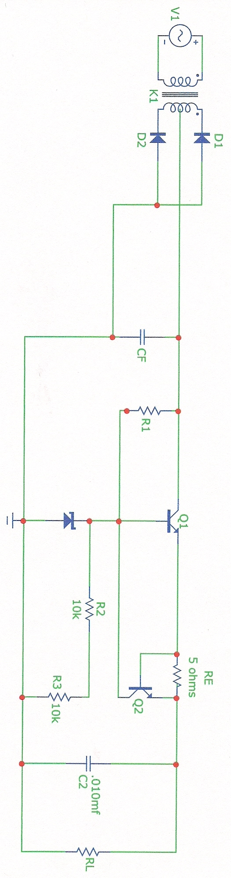  .14 | $$11.18$$ | $$V cfpp-ripple$$
Full Load | $$.13$$ | $$10.94$$ | $$V zenerpp-ripple$$
 |  |  | $$Voutpp-ripple$$

- Low line no load measurements (Variac Voltage = 105):
- V out-dc= 6.084V VR6= 6.26v R6= 3k
- I Load= 0
- V-out-pp-ripple = 2.568V
- V zener= 4.998V
- V zener-pp-ripple = 230$μ$V
- V cf = 16.7V
- V cf-pp-ripple = 2.56V

- High line no load measurements (Variac Voltage = 120):
- V out-dc= 6.473V
- I Load= 0
- V-out-pp-ripple = 2.94V
- V zener = 5V
- V zener-pp-ripple = .210mV
- V cf = 18.255V
- V cf-pp-ripple = 1.01V

- Low line no load measurements (Variac Voltage = 105 / R-load = 100 ohms):
- V out-dc= 8.519V
- I Load= 85.1mA
- V-out-pp-ripple = 9.99V
- V zener= 4.968V
- V zener-pp-ripple = 62.9mV
- V cf = 10.840V
- V cf-pp-ripple = 11.14V

- High line no load measurements (Variac Voltage = 120 / R-load n= 100):
- V out-dc= 10.085V
- I Load= 100.85mA
- V-out-pp-ripple = 11.83V
- V zener = 4.977V
- V zener-pp-ripple = 53mV
- V cf = 12.546V
- V cf-pp-ripple = 13.18V

Performance parameters for the power supply obtained from part (a) through (d) with the above calculations.
- The output % line regulation at no load:
$$\left(\frac{6.473v-6.084v}{6.473v}\right)*100=6.01$$

$$\left(\frac{18.255v-16.7v}{18.255v}\right)*100=$$

- The output % line regulation at full load:
$$\left(\frac{12.54v- 10.84v}{12.54v}\right)*100=$$
$$\left(\frac{10.085v-8.519v}{10.085v}\right)*100=15.53$$

- The output % load regulation at low line:
$$\left(\frac{8.519v-6.084v}{8.519v}\right)*100=28.58$$

$$\left(\frac{16.7v-10.84v}{16.7v}\right)*100=$$

- The output % load regulation at high line:
$$\left(\frac{10.085v-6.473v}{10.085v}\right)*100=35.82$$

$$\left(\frac{18.255v-12.54v}{18.255v}\right)*100=$$

- The ripple rejection in db from input to the zener:
20$log({V cf-pp-ripple })$=

- The ripple rejection in db from the zener to the output
20$log({V zener-pp-ripple })$=

- The ripple rejection in db from input to output:
20$log({V out-pp-ripple })$=

Tabulated Calculations:
Output % Line and Load Regulation
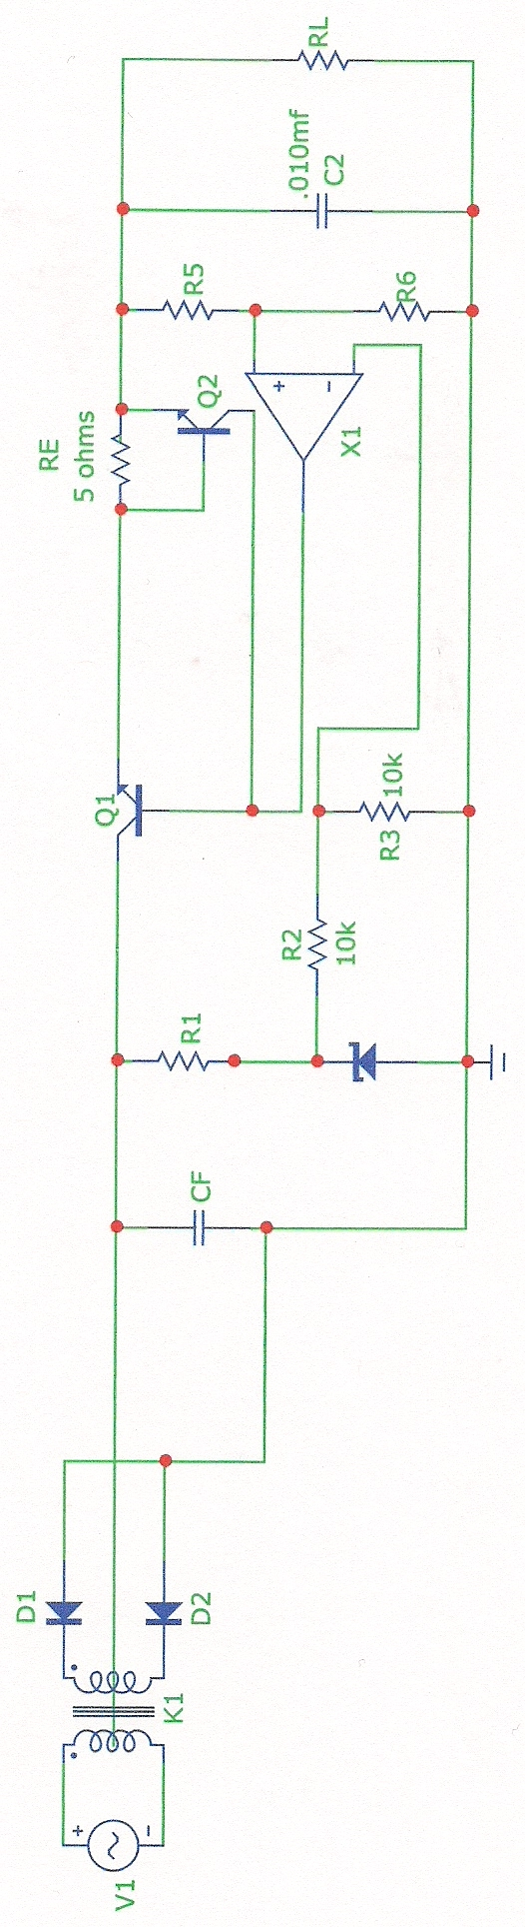 | Line Regulation | Load Regulation | Parameters | Ripple Rejection in db
No load | $$6.01$$ | $$35.82$$ | $$V cfpp-ripple$$
Full Load | $$15.53$$ | $$28.58$$ | $$V zenerpp-ripple$$
 |  |  | $$Voutpp-ripple$$

Tabulated Calculations (1):
Output % Line and Load Regulation
 | Line Regulation | Load Regulation | Parameters | Ripple Rejection in db
No load | .14 | $$11.18$$ | $$V cfpp-ripple$$
Full Load | $$.13$$ | $$10.94$$ | $$V zenerpp-ripple$$
 |  |  | $$Voutpp-ripple$$
Tabulated Calculations (2):
Output % Line and Load Regulation
 | Line Regulation | Load Regulation | Parameters | Ripple Rejection in db
No load | $$6.01$$ | $$35.82$$ | $$V cfpp-ripple$$
Full Load | $$15.53$$ | $$28.58$$ | $$V zenerpp-ripple$$
 |  |  | $$Voutpp-ripple$$

